Dr Graeme Hogarth (King’s College London)
Hydrogenase biomimics: Role of 4 billion year old organometallic enzymes in the H₂ economy
The clean production of hydrogen from renewable sources utilising earth-abundant catalysts is a major societal challenge. In this talk we will use nature as an inspiration. Hydrogenases, [FeFe]ases, are ancient enzymes capable of catalysing the reversible formation of hydrogen from protons and electrons. The active site of [FeFe]ases contains six iron atoms, a well-known ferredoxin sub-unit being linked to an unusual diiron carbonyl-cyanide stabilised centre via a cysteine group. In our work we have been concerned with both gaining a better understanding of how these enzymes work, while having the major goal of preparing cheap and robust iron complexes that can act as functional mimics, thus allowing the industrial scale production of hydrogen from renewable sources (wind, wave, solar etc.) and protons. In this talk we will consider four aspects of this work, (i) differentiating between the catalytic activity of isomeric diiron complexes, (ii) the interaction between the catalytically active diiron centre and an attached redox-active ligand, (iii) the potential use of triiron complexes s catalysts containing a proton-shuttle and (iv) an enzyme mimic that can both catalyse the production and oxidation (essential to a fuel cell) of hydrogen.
Hydrogenase biomimics containing redox-active ligands: Fe₂(CO)₄(μ-edt)(κ²-bpcd) with electron-acceptor 4,5-bis(diphenylphosphino)-4-cyclopenten-1,3-dione (bpcd) as a potential [Fe₄-S₄]_{H} surrogate, S. Ghosh, N. Hollingsworth, M. Warren, D.A. Hrovat, M.G. Richmond and Graeme Hogarth, Dalton Trans., 2019, 48, 6051-6060.
Models of the [FeFe]-hydrogenase enzyme: Synthesis, structure, electrochemistry and catalytic activity of [Fe₂(CO)₃(μ-dithiolate){μ,η²-Ph₂PCH₂CH₂P(Ph)CH₂CH₂PPh₂}], D. Unwin, S. Ghosh, F. Ridley, M.G. Richmond, K.B. Holt and G. Hogarth, Dalton Trans., 2019, 48, 6174-6190.
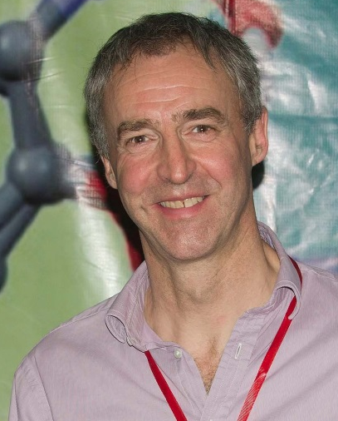
Graeme Hogarth joined King’s College London as Director for Teaching and Learning in early 2014 after spending the previous 25 years across London at University College London. His research interests cover a wide range of applications of transition metal chemistry current themes being the synthesis of bio-inspired base metal catalysts for the clean formation of hydrogen and applications of functionalised dithiocarbamate complexes in chemistry, materials science, anti-cancer drugs and radiopharmaceuticals. Outside of chemistry he can often be found on a squash court, where he coaches and competes, or watching his sons play ice hockey.

